Oldham Community Leisure

Exercise Referral Scheme
Guidance for Health Professionals
2017

Why physical activity?
Healthcare professionals have a critical role in supporting every day activity across the life course. One in four people would be more active if they were advised by a GP, practice nurse or physio. Less than half however say they receive such advice. It is recognised that time is under pressure in a clinical environment, but brief advice is proven to be effective given by those with appropriate knowledge.
The evidence base for physical activity in the treatment and prevention of the majority of diseases is very strong with new evidence emerging all of the time. NICE has a whole host of evidence to support physical activity amongst adults, all of which can be accessed at www.nice.org.uk.
On average, an inactive person spends more days in hospital than an active person, and has more family physician visits, requires more specific service intervention and more nurse visits than an active individual.
Physical activity interventions have also been shown to be a highly cost-effective use of public funds in primary care, environment and workplace settings.
Physical inactivity is one of the top ten causes of UK ill health, responsible for 1 in 6 deaths.
The North West is the worst place in the country for exercise, with millions putting their life at risk according to the British Heart Foundation. They believe inactivity costs the NHS nationally around £1.2bn each year. The charity found 47%, or 2.7 million adults, in the North West are insufficiently active increasing their risk of heart disease.
The information below gives guidance on the benefits of exercise.

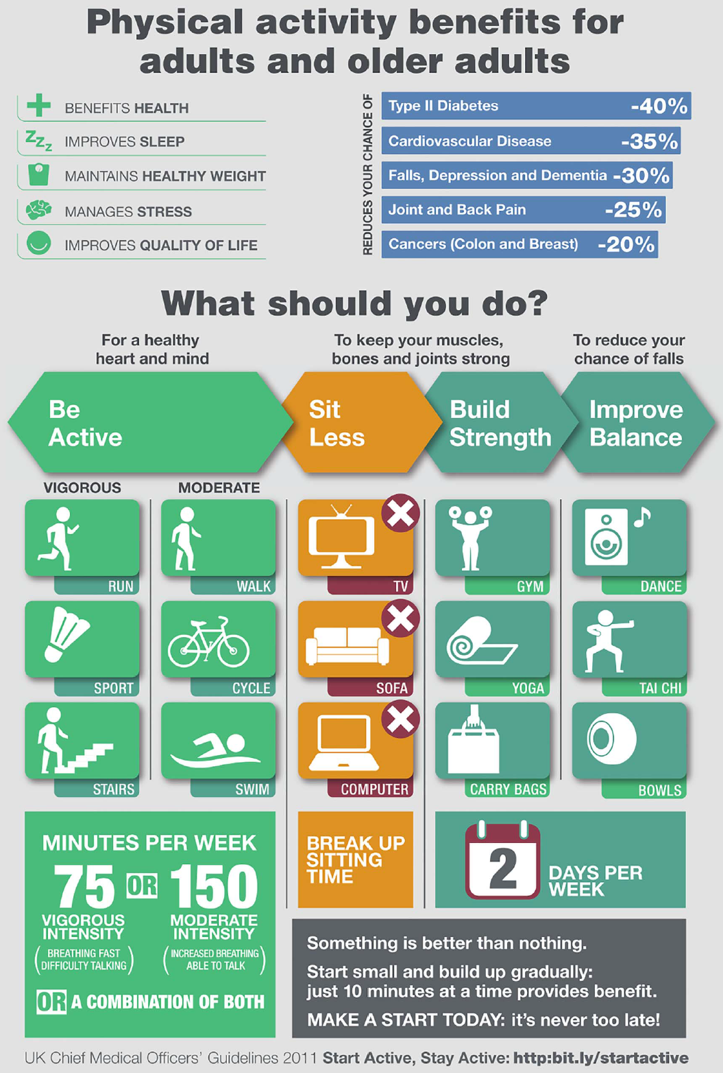

Why exercise referral?
Exercise referral has been operating in Oldham for many years. It offers adults who have a medical condition/s or disability the opportunity to become more active, as a way of managing or improving health or a way of preventing additional health needs.
Exercise referral can help patients to achieve the recommend CMO’s physical activity guidelines of 150 minutes of moderate physical activity per week.
The scheme currently provides physical activity opportunities in:
- Cardiac, COPD and Stroke rehabilitation classes
- Access to over 150 supervised classes per week on OCL ‘Easy Does It Programme’
- Swimming (recreational and unsupervised)
- Support from advanced fitness instructors with specialist knowledge around exercise referral.
Patients can choose to do a mixture of activities whilst on the programme for a minimum of 12 weeks. For the first 4 week patients are encouraged to attend supervised classes only.
Patients attend an initial assessment with an exercise referral specialist instructor and are offered the opportunity to attend additional appointments at week 12. OCL will also contact participants by telephone at week 10 to check on progress, discuss any problems and provide relevant information and advice.
The scheme in Oldham operates at:
- Chadderton Wellbeing Centre
- Oldham Leisure Centre
- Failsworth Sports Centre
- Saddleworth Leisure Centre
- Royton Leisure Centre
The scheme aims to meet best practice guidance as stated by the DoH National Quality Assurance Framework (2001), DoH Statement on Exercise Referral (March 2007), NICE Guidelines on Exercise Referral (November 2014) and BHF Exercise Referral Toolkit. Oldham CCG provides financial support and directional support for the specialist classes.
Evaluation of the exercise referral scheme is done continually and a report containing the findings is completed annually.
How do I decide if exercise referral is best for my patient?
This relies on your clinical judgement. Generally referrals for exercise are most suitable for patients who are insufficiently active and need help with motivation, exercise programming, need supervision/monitoring/increased assistance in selecting the most appropriate type of activity.
We do not accept referrals for people who are sedentary or inactive but otherwise apparently healthy. However we do accept referrals for people who are sedentary or inactive and have an existing health condition.
Use the chart to help you decide as to whether exercise referral is most appropriate for your patient:
Has a long-term medical condition | Yes
Requires activity for specific health outcomes | Yes
Requires tailored exercise programming | Yes
Needs motivational support | Yes
Is inactive and sedentary and got existing medical condition | Yes
Is inactive and sedentary with no medical health conditions | No
Ready to give activity a go! | Yes
Medically stable | Yes
Awaiting cardiac investigation | No
Lives or works in Oldham and has an existing health condition | Yes
Is able to pay exercise referral costs * see info below about fees | Yes

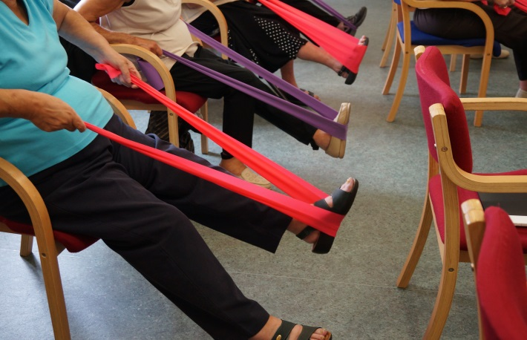

Inclusion/Exclusion Criteria
The patient must be sedentary (defined as not moderately active for 3 or more times per week or deconditioned through age or inactivity), and have at least one of the following medical conditions:
CHD risk factors | Mental Health | Musculoskeletal | Neurological Conditions | Respiratory/pulmonary
Raised blood pressure more than 140/90 (either) but less than 180/100 (either) | Mild anxiety, depression or stress | At risk of Osteoporosis | Multiple sclerosis | Chronic obstructive pulmonary disorder (COPD)
Weight Management |  | Arthritis (mild) |  | Mild/moderate well controlled (Asthma, bronchitis, emphysema)
BMI greater than 35 |  | Poor mobility |  | Heavy Smoker
Controlled Diabetes |  | Musculoskeletal pain including back pain |  | Chronic Fatigue
High cholesterol greater than 5.0
Family history of heart disease or diabetes
Referral from Cardiac Rehabilitation (only from phase IV).
Stroke
PAD

Also included
Clients with Dementia
Cancer

For other health conditions not listed above please contact us direct to discuss if they can be referred onto the scheme.

Exclusion Criteria
Aged 16 or under | Unstable Angina | Blood Pressure 180/100 (in either) or above and/or uncontrolled or poorly controlled hypertension | Cardio Myopathy | Uncontrolled Tachycardia
Cardio Arrhythmia | Valveular Heart Disease | Congenital Heart Disease | Unexplained dizzy spells | Excessive or unexplained breathlessness on exertion
Uncontrolled or poorly controlled diabetes | Uncontrolled or poorly controlled epilepsy | History of falls or dizzy spells in the last 12 months | Uncontrolled or poorly controlled (severe COPD) | First 12 weeks of pregnancy
Awaiting medical investigations | Already taking part in regular exercise and not exercised for the last 6 months

Customers who are already members of Oldham Community Leisure
Customers who are already members of Oldham Community Leisure or have been a customer within the previous 6 months will not be entitled to join the exercise referral scheme. However if an existing customer would like advice and support from the team, this would be offered. Previous members within the 6 months would not be offered the discounted membership.
Please note this scheme is not free.
The cost for the initial consultation and programme is free, but the cost to attend all sessions are heavily discounted. The fees are up to 50% cheaper. OCL also offer a highly discounted membership which is optional for patients and is valid for 12 months.
What if my patient have had a history of heart problems – can I still refer?
For patients that have diagnosed coronary heart disease, angina, stroke have had a myocardial Infarction, cardiac surgery, pulmonary disease or peripheral arterial disease additional information about the patient is required, above and beyond the general exercise referral form. Specific forms can be obtained by contacting: reach@ocll.co.uk or you can download from the exercise referral webpage. www.oclactive.co.uk
Only the patient’s GP can complete the BACR, CHD, COPD and Stroke form. If you are allied health professional wishing to refer a patient please direct the patient to their GP.
Transfers are welcomed and accepted directly from Phase III to our Phase IV classes from the cardiac rehabilitation, Pennine Lung Service, Tissue Viability team and the stroke rehabilitation team.
How do I become involved?
National guidance for exercise referral currently states that referrals can be accepted by the following health professionals:
- Doctors
- Nurses – including community, mental health, condition specific (such as respiratory, cardiac)
- Occupational Therapists
- Physiotherapists
- Dieticians
Prior to referring a patient for the first time, you must register your interest to do so and agree to the terms and conditions of the scheme. Upon registering you will be sent a downloadable copy of the referral form and will be automatically added to the OCL health professional database. You will be sent regular updates on the schemes. Upon completing a referral form, please fax to Oldham Community Leisure on 0161 628 6973 and also hand a copy to the patient. The scheme co-ordinator will make contact the patient to organise the first appointment. See chart below of the full programme your patient will follow.

Oldham Community Leisure Exercise Referral Scheme
Rehab Programme with Specific Exercise Component
Cardiac Pulmonary
Heart Failure
Pain
Stroke
PAD
Health Educational
Diabetes Programmes

Primary Care
Obesity
Blood Pressure
Musculoskeletal
Depression
Impaired Glucose Tolerance
Health Interface

Specific Exercise Component Level 4 Instructor

Exercise Referral Scheme

Generic Exercise Referral Level 3 Instructor
Lifestyle behaviour change/advice intervention delivered by a qualified exercise referral advisor

Level 2/3 Instructor
To deliver exit for Exercise Referral and entrance to

Ongoing Activity
Swimming Walking Football Yoga Pilates
Chair Based Exercise Dance Low Impact aerobics
Tai Chi Bowls Gym Based Activity
MAINSTREAM LEISURE AND COMMUNITY ACTIVITIES

Oldham Community Leisure Exercise Referral Flow-Chart
Referral Form Received
Group Consultation
- Lifestyle questionnaire
- Physical activity leaflet
- Tour of facilities
- Introduction of scheme
- Talk about benefits of exercise
- The OCL offer
- Book in for 1 to 1 Programme
- Enter info onto data base
- Goal Setting

Exercise Co-ordinator
Book into 1st Group Consultation via Contact Team/On Line/HAPAT Team
Active Card Set Up

Group 1st Consultation with option of 1 to 1 for more complex clients

1 to 1 Appointment
Physiological tests
Individual Goals Discussed
Telephone Consultation if Swim/Class Only
Plan/Programme
Option of Supervised Classes
1 to 1 Consultation/Programme

Begin 12 Week Exercise Programme

- 30 Minute Review of Programme
- Review of goal setting
- Review of progress
- Relapse Prevention
- Discuss progress with client and look at other opportunities
- Option for membership offers
- MECC Info

10 Week Follow Up
Follow Up Phone Call
- Lifestyle Questionnaire
- Discussion on future plans
- Relapse prevention

12 Week Final Consultation

12 Month Questionnaire
One Year
Consultation Questionnaire
Feedback given to all referral agencies and project reports completed

What happens when the patients finishes the initial scheme?
OCL will monitor usage for 12 months; all patients will be encouraged to continue exercise after the schemes finished. They would be no benefit of exercising for 12 weeks and then stopping. The instructors will motivate, encourage and advice on the most safe and effective exercise to meet the patients individual needs.
Once the patients completed the scheme, a report will be sent back to the referring agency showing the patients progress.
Exercise referral contact information:
For more information about the scheme, please visit:
www.oclactive.co.uk
https://oclactive.co.uk/activities/oldhams-exercise-referral-scheme/
Alternatively contact the Health and Physical Activity Team on:
0161 621 3352 (General Exercise Referral) referral@ocll.co.uk
0161 621 3353 (Rehab Exercise Referral) reach@ocll.co.uk
Secure Fax Number: 0161 628 6973
Please do not send patient information via e-mail.

Address:
C/O Exercise Referral Co-ordinator
Oldham Community Leisure
Burnley Street
Chadderton
Oldham
OL9 OJW

