Reception Vacancies
Oldham Leisure Centre and Royton Leisure Centre
Various Hours
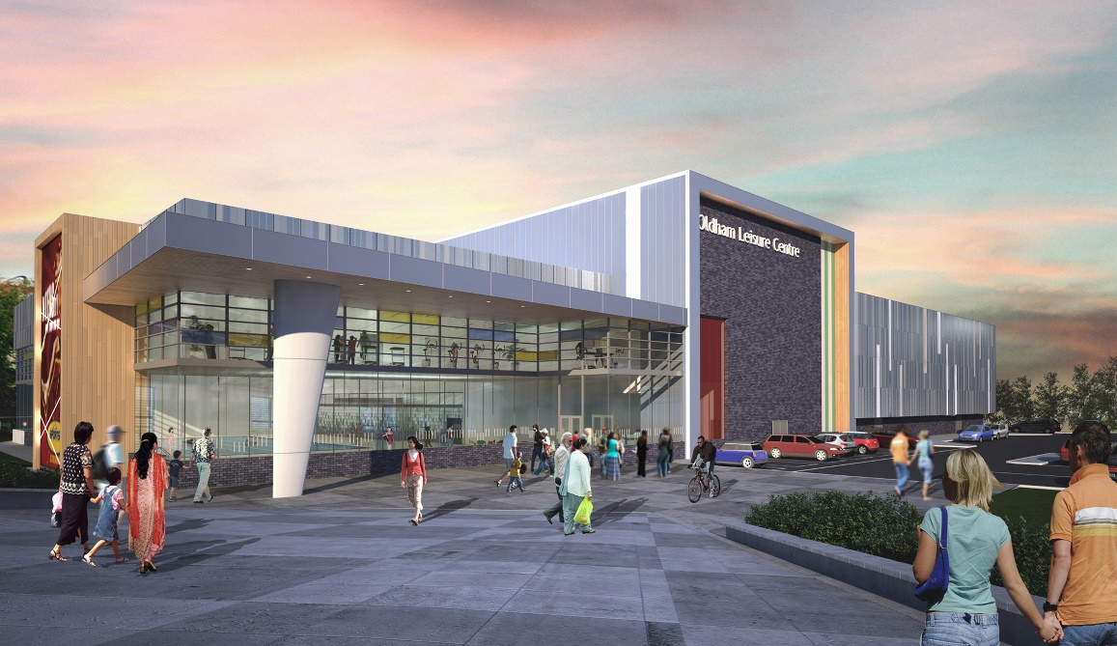
Do you have what it takes to be part of the team and to provide a first class customer service across sports centres in the OCL group?
With continued growth in our sites it will be hectic and expectations for high standards are always there- If this still appeals to you and you are looking to prove your skills as a customer service professional we want to hear from you.
Applications are invited from individuals who will provide a front house service incorporating bookings, cashier and clerical support to the centre whilst working with a computerised booking system and maintaining excellent Customer Care.
The role of the receptionist is to act as a point of contact for all centre enquiries either by telephone, email or face to face and contribute to the smooth running of the centre reception. It is desirable that individuals should be educated to NVQ level 2 and have previous experience of working in a customer service environment.
The rate of pay for the role is the National Living Wage.

As part of OCL’s total reward package there is a generous holiday entitlement which is over and above the statutory minimum, a pension scheme into which the company contributes, you will be provided with full uniform and any equipment required to undertake your job role. Also offered is free parking and use of the facilities. The rate of pay for the role is OCL Band 2 which commences at £6.75 per hour and rises to £8.91, dependent upon age.

If after reading above you feel that you have what it takes and want to join a great team, apply on line at www.oclactive.co.uk/vacancies. The closing date for receipt of applications is 31st January 2022. OCL are an equal opportunities employer and welcome applications from all.

